JOB PORTAL MANAGEMENT

SYSTEM

Submitted by**: Hiba Noushad**

Table of Contents Page no

1. Introduction

* 1. Purpose 3
  2. Scope 3
  3. Objective 4

1. Functional Requirements
   1. System Actors
      1. Platform Admin 4
      2. Job Provider 4
      3. Job Seeker 5
   2. Use Case Diagrams
      1. Platform Admin Use Case 5
      2. Job Provider Use Case 6
      3. Job Seeker Use Case 6
   3. User Stories
      1. Platform Admin Stories 7
      2. Job provider Stories 8
      3. Job Seeker Stories 8
   4. Process Flow
2. Non-Functional Requirements
   1. Performance 9
   2. Security 10
   3. Usability 10
   4. Reliability 11
3. Technical Requirements 12
   1. System Architecture 13 1Technology Stack

**1. Introduction**

**1.1** **Purpose**

This Software Requirements Specification (SRS) document is developed to serve as a comprehensive blueprint for the design, development, and implementation of the [Project Name] system. It aims to provide a detailed and precise description of the system’s intended functionality, performance characteristics, and operational constraints to ensure a clear and shared understanding among all stakeholders, including developers, clients, testers, and project managers. The document acts as a contractual agreement between the stakeholders and the development team, ensuring that the software delivered aligns with the expectations and needs of the business. By outlining the goals, context, and rationale behind the system, this document establishes a strong foundation that will guide the software throughout its life cycle—from initial conception to final deployment and subsequent maintenance. The purpose of this SRS is not only to provide clarity and direction but also to serve as a reference point for future changes and enhancements to the system, minimizing ambiguity and supporting effective project management.

**1.2 Scope**

The [Project Name] system is being developed to address specific operational challenges and streamline existing processes within the organization by introducing a robust, scalable, and user-friendly software solution. The system will primarily be responsible for managing [key functional areas, e.g., user accounts, scheduling, data analytics, etc.], and will cater to various user roles such as [e.g., administrators, employees, clients], each with distinct access rights and functionalities. It will include multiple integrated modules such as [e.g., authentication, reporting, notification, and task automation], which work together to provide a seamless experience across devices and platforms. Additionally, the software will support interoperability with external systems through APIs or third-party services where applicable, enabling smooth data exchange and reducing manual intervention. The scope of this project also includes responsive design for cross-platform compatibility, secure data handling practices, and support for future feature enhancements. However, it does not cover hardware procurement, third-party software licensing, or long-term hosting and infrastructure support, which are considered out of scope and the responsibility of the client or hosting partner.

**1.3 Objectives**

The primary objective of the [Project Name] system is to provide a reliable and efficient software platform that meets the specific needs of its intended users while aligning with organizational goals such as productivity improvement, cost reduction, and enhanced

data management. This will be achieved through the development of a high-quality system that offers intuitive navigation, fast performance, robust data security, and flexibility to adapt to future requirements. One of the key aims is to automate manual and repetitive tasks, thus reducing human error and freeing up user time for higher-value activities. In addition, the system seeks to enable real-time data access and reporting, which will support informed decision-making at various organizational levels. The system will also be designed with scalability in mind to accommodate growth in user base and feature complexity without significant redesign. Ultimately, the software will act as a central platform that consolidates multiple operational functions into a cohesive, streamlined, and user-centric solution that delivers measurable improvements in both day-to-day workflows and long-term strategic outcomes.

**2. Functional Requirements**

**2.1.1 Platform admin**

A platform admin is responsible for managing and maintaining the overall functionality, security, and performance of a digital platform or system. Their role includes user management, access control, configuring system settings, monitoring platform activity, troubleshooting issues, and ensuring that the platform operates smoothly for all users. They often serve as the primary point of contact between users and technical support, enforce compliance with organizational policies, and may coordinate with developers to implement updates or new features. A skilled platform admin plays a key role in ensuring a reliable and efficient user experience.

The platform admin a key figure in ensuring the seamless operation and security of a digital platform, whether it's a learning management system, enterprise software, e-commerce site, or community portal. Their responsibilities extend beyond basic user management to include configuring system settings, integrating third-party tools, managing data backups, and overseeing platform updates. They often monitor system performance, resolve technical issues, and provide support to users, ensuring that everyone from end-users to stakeholders can interact with the platform efficiently. A platform admin also plays a strategic role in implementing security protocols, managing permissions and access levels, and enforcing compliance with data privacy regulations. By staying up to date with technology trends and platform enhancements, they help guide the system’s development and scalability. Their work ensures that the platform remains stable, secure, and aligned with the goals of the organization it supports.

**2.1.1 job provider**

A job provider is an individual, company, or organization that offers employment opportunities to job seekers. Their primary role is to create and maintain positions that contribute to the organization’s goals while offering fair compensation and growth opportunities to employees. Job providers are responsible for defining job roles, conducting recruitment processes, and ensuring a productive and respectful work environment. By offering employment, they contribute to economic development, skill enhancement, and social stability within communities.

The job provider plays a vital role in the employment ecosystem by offering work opportunities to individuals across various skill levels and industries. Whether they are private companies, public institutions, or staffing agencies, job providers actively participate in identifying talent, conducting interviews, and placing candidates in roles that match their qualifications and potential. They contribute to workforce development by offering training, promoting career advancement, and ensuring fair practices. In addition to fulfilling organizational needs, job providers support economic growth and social well-being by reducing unemployment and empowering individuals with financial independence. By maintaining a balance between operational efficiency and employee satisfaction, job providers help create sustainable work environments where both employers and employees can thrive.

**2.1.3 job seeker**

A job seeker is an individual actively looking for employment opportunities that match their skills, experience, and career goals. Job seekers may be recent graduates entering the workforce, professionals seeking new challenges, or individuals re-entering the job market. Their search involves preparing resumes, applying to suitable positions, attending interviews, and often upskilling to meet evolving industry demands. In addition to technical abilities, job seekers must demonstrate adaptability, communication skills, and a proactive attitude to stand out in competitive markets. Whether seeking part-time, full-time, remote, or freelance roles, job seekers play a crucial role in the market by connecting talent with opportunities that drive personal growth and organizational success.

The individual actively engaged in the pursuit of employment, driven by a desire to advance their career, gain new experiences, or renter the workforce. Job seekers come from diverse backgrounds, ranging from fresh graduates and experienced professionals to those making a career transition or returning after a break. Their journey typically involves researching job markets, tailoring resumes and cover letters, networking with industry professionals, and preparing for interviews. Many also pursue professional development through certifications, courses, or volunteer work to remain competitive and relevant in their chosen field. In addition to technical qualifications, job seekers must exhibit soft skills such as adaptability, communication, problem-solving, and resilience, especially in a rapidly changing job landscape. Job seekers often leverage online job boards, recruitment agencies, social media, and career fairs to explore opportunities. Their proactive efforts not only full fill personal and financial goals but also contribute to workforce mobility, innovation, and economic growth.

**User case Diagram**

**Platform admin**

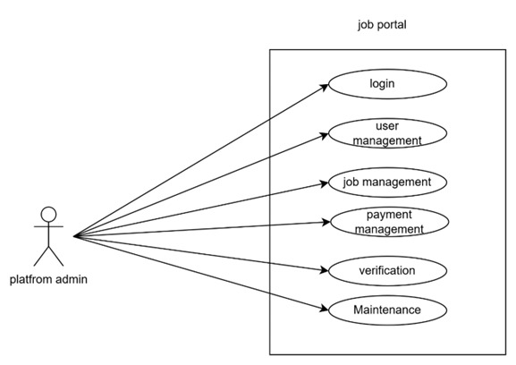

**Job Provider**

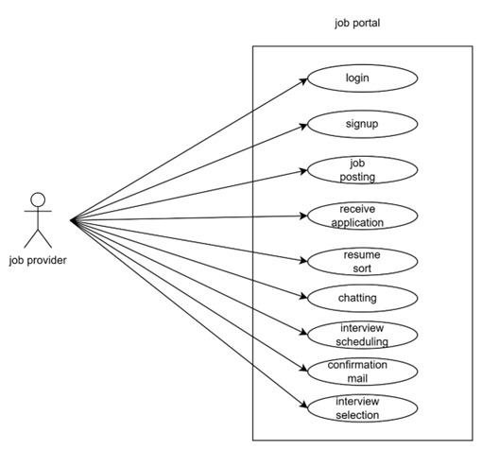

**Job Seeker**

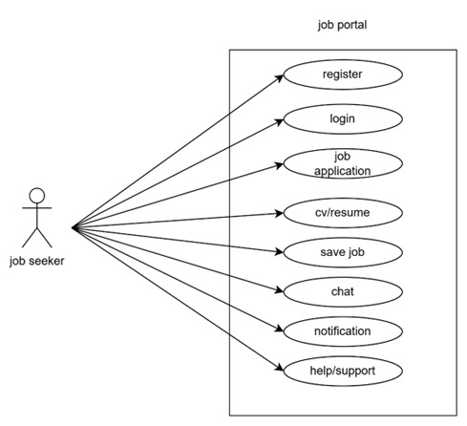

**User Stories**

**Platform admin**

|  |  |  |
| --- | --- | --- |
| AS a (type of user) | I need to (do some task) | So that I can (get some result) |
| Platform admin | Login to the portal by entering details | Ensure a authorized access to the platform, different user have different login details |
| Platform admin | Maintain user accounts and permission | Allows job seekers and employers to create profiles, providing essential detail, job seekers can track application status |
| Platform admin | Maintain payments and subscription | Ensure to unlock premium levels, user can upgrade or cancel subscription, improves the growth |
| Platform admin | Job management and details | Ensure accurate, up-to—date listing for job seekers, help user to get the job opportunities easily |
| Platform admin | Perform regular updates and maintenance | Keep the platform running smoothly without any error or buys |

**Job provider**

|  |  |  |
| --- | --- | --- |
| AS a (type of user) | I need to (do some task) | So that I can (get some result) |
| Job provider | login | Register and job details |
| Job provider | Finding candidates | Searching people who have the right skill and experience |
| Job provider | Posting job advertisements | Sharing with website, newspapers, or social media |
| Job provider | Receive application | Checking resumes and application to short list |
| Job provider | Coordinating interviews | Scheduling meeting with candidates |
| Job provider | Conformation mail | Helping candidates improve if they don’t get selected or select |

**Job Seeker**

|  |  |  |
| --- | --- | --- |
| AS a (type of user) | I need to (do some task) | So that I can (get some result) |
| Job seeker | Login into the application by  Entering personal details | Access the plat form to find opportunities |
| Job seeker | Upload my CV/resume | Showcase my skills and provide details to the job provider |
| Job seeker | Seach and apply for the job | Be eligible in the eyes of the employer in order to obtain the desired position |
| Job seeker | Save job | I can apply later or track interesting jobs |
| Job seeker | Message and get notifications | I can keep contact with the employers |
| Job seeker | Access help/support | I can resolve any issues with the account |

**2.4 Business Process flow**

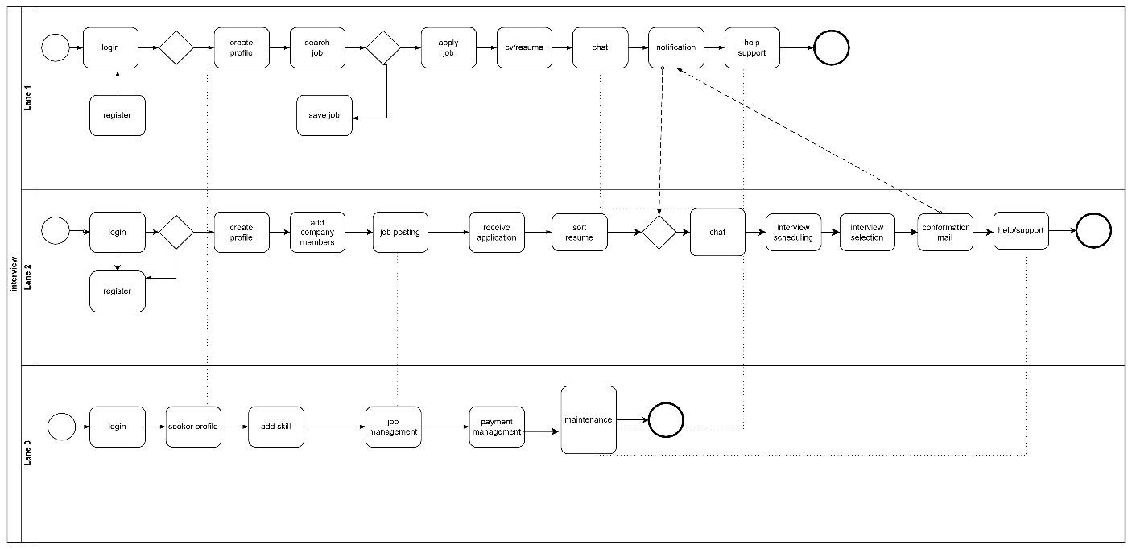

**3. Non-Functional Requirements**

**Common Types of Non-Functional Requirements:**

**3.1 Performance**

Performance refers to how well a system executes its functions under defined conditions and is a key non-functional requirement that directly affects user satisfaction, system efficiency, and business outcomes. It includes several measurable attributes such as response time (the time taken to respond to user inputs), throughput (the number of transactions or operations a system can process within a given time), latency (delay before a transfer of data begins), and **resource** utilization (how effectively the system uses CPU, memory, and bandwidth). Performance requirements are often critical in real-time systems, financial platforms, streaming services, and large-scale enterprise applications where delays or inefficiencies can lead to poor user experiences or financial loss. For instance, an e-commerce site might require that product pages load within 1.5 seconds during peak traffic hours, while a banking system might demand transaction processing within milliseconds. Performance also involves scalability—how well the system maintains its speed and responsiveness as the load increases—and concurrency, ensuring the system can handle multiple simultaneous users or processes without degradation. These requirements are typically validated through performance testing, including load testing, stress testing, and endurance testing, and must be clearly defined during the planning and design stages to ensure the final system meets business and technical expectations.

**3.2 Security**

Security, as a non-functional requirement, refers to the protection of a system and its data from unauthorized access, misuse, breaches, and other cyber threats. It ensures that sensitive information such as user credentials, personal data, and financial records is safeguarded through authentication, authorization, encryption, and auditing mechanisms. A secure system must verify the identity of users (authentication), restrict access based on roles (authorization), encrypt data in transit and at rest, and log activity for monitoring and compliance. Security also involves protecting against threats such as SQL injection, cross-site scripting (XSS), malware, and denial-of-service (DoS) attacks. Compliance with industry standards like ISO/IEC 27001, GDPR, or HIPAA may also be required, depending on the domain. Security requirements should be considered early in the development process to build trust with users, protect organizational assets, and reduce the risk of legal and financial consequences from breaches.

Security is a critical non-functional requirement that ensures the confidentiality, integrity, and availability (CIA) of a system and its data. It involves designing and implementing controls to prevent unauthorized access, data breaches, malicious attacks, and operational disruptions. A secure system enforces authentication (verifying user identity), authorization (granting access rights based on user roles), encryption (protecting data in transit and at rest), and audit logging (recording user actions for traceability). Security also includes input validation to prevent code injection and secure session management to avoid hijacking attacks. Advanced measures such as multi-factor authentication (MFA), firewalls, intrusion detection/prevention systems(IDS/IPS), and regular vulnerability assessments help strengthen defines. Moreover, systems should have clearly defined security policies, incident response plans, and backup andrecovery procedures to handle breaches or failures effectively. Security requirements must align with legal and regulatory standards like GDPR, HIPAA, PCI-DSS, 27001 or ISO, depending on the domain and data sensitivity. These requirements should be integrated into the system architecture from the outset, not added as an afterthought, and should be continually evaluated through penetration testing, code reviews, and security audits to adapt to evolving threats. A well-secured system not only protects assets and user trust but also supports business continuity and compliance.

**3.3 Usability**

Usability, as a non-functional requirement, refers to how easy, intuitive, and efficient a system is for users to learn, navigate, and interact with. A highly usable system minimizes the learning curve and reduces user errors by offering clear navigation, consistent design, helpful feedback, and accessible content. It focuses on user-centered design principles, ensuring that users can complete tasks with minimal frustration or confusion. Usability includes aspects such as learnability (how easy it is to start using the system), efficiency (how quickly users can perform tasks), memorability (how easily users can return to the system after a break), error prevention and recovery, and satisfaction (how pleasant the experience is). Usability testing with real users is often conducted during development to gather feedback and make improvements. A system with strong usability enhances user productivity, engagement, and overall satisfaction, which is especially critical in consumer-facing applications, educational platforms, and enterprise software.Usability is a key non-functional requirement that determines how effectively, efficiently, and satisfactorily users can interact with a system. It encompasses the overall user experience (UX) and focuses on making systems intuitive, easy to learn, and pleasant to use. Usability includes several core attributes:

**3.4 Reliability**

Reliability, as a non-functional requirement, refers to the ability of a system to perform its intended functions consistently and accurately over time, without failure. A reliable system maintains correct operation under normal and anticipated conditions, ensuring users can depend on it for continuous service. Key attributes of reliability include availability (the system is operational when needed), fault tolerance (the system can continue to operate even if parts fail), recoverability (the ability to restore functionality quickly after a failure), and accuracy (producing correct outputs consistently). Reliability is especially critical in systems where failure can lead to significant consequences, such as in healthcare, aviation, finance, or industrial automation. It is often measured through metrics like mean time between failures (MTBF) and mean time to repair (MTTR). Ensuring reliability involves rigorous testing (e.g., stress, load, and endurance testing), redundancy planning, automated monitoring, and quick-response incident handling. A reliable system builds trust with users, reduces downtime, and supports the long-term success and stability of the organization.

**4.Technical Requirements**

|  |  |
| --- | --- |
| Processor | Intel Core i5 |
| Hard Disk | 40GB to 80GB |
| Memory | 8GB |
| OS | Windows 11 |
| Front end | HTML, CSS, JavaScript, Bootstrap and Angular |
| Back end | C# |
| Database | MS SQL |
| Framework | ASP.NET core |
| IDE | Visual Studio |

|  |  |
| --- | --- |
| **5 Conclusion**  In conclusion, this Software Requirements Specification has outlined the functional and non-functional requirements essential for the successful development of the [Project Name] system. It serves as a foundational document ensuring all stakeholders have a shared understanding of the project's scope, objectives, and constraints. Adherence to the requirements defined herein will guide the development team toward delivering a robust, efficient, and user-centered solution. Future updates to this document should be managed through a structured change control process to maintain alignment with evolving business needs and technological advancements. |  |
|  |  |
|  |  |
|  |  |
|  |  |
|  |  |
|  |  |
|  |  |
|  |  |
|  |  |
|  |  |